EXTRACT OF APPENDICES A AND B

FROM:

NOTES ON ADMINISTRATION

For the

NATION BUILDING PROGRAM

For projects funded under
Parts 3 and 6 of the
Nation Building Program (National Land Transport) Act 2009
where payments are made directly to a State, an authority of a State or any other body corporate

ISSUE DATE

July 2009

APPENDIX A: PROJECT PROPOSAL REPORT (PPR)
All questions must be answered unless specifically directed otherwise within the body of the PPR. Proponents should consider providing additional information where such information could assist the Department with the appraisal of the PPR. Any supporting documentation should be referred to within the body of the PPR.

Refer to 3.2 (Project phases) to determine the appropriate scope for the PPR.

A. PROPONENT AND PROJECT DETAILS Proponent Details

A1 ABN/ACN and registered Entity Name

A2 Project Director and/or Manager (name, telephone, facsimile, e-mail and postal address)

Project Details

A3 Project ID

A4 Project Name

A5 Project Scope

A6 Geographical References

A7 Project Summary
A8 Which corridor and section of the National Network is the project located on? A9 Under which category of the Act is the project eligible for approval?
Part 3, Division 1, Section 10: (a)/(b)/(c)/(d) Part 6, Division 1, Section 54: (a)/(b)/(c)/(d)/(e)

A10 For which project phase(s) is this PPR seeking funding? (select all applicable)

□ Scoping □ Development □ Delivery

B. |  | STRATEGIC FIT
 | B1 | Has the Scoping Phase previously been approved? | YES / NO
 | B2 | Is the project identified in the MOU? | YES / NO
 | B3 | Has it been determined that the project has strategic merit
 |  | through a formal Strategic Merit Test?  (Provide details including the date of determination) | YES / NO
If the answer to all of the above questions is ‘NO’, do not proceed with completion of this PPR. A project will not be determined appropriate to approve for release of funds unless it has been determined to have strategic merit.

C. PLANNED OUTCOMES AND OUTPUTS

C1 Describe the performance objectives and intended outcomes for this project. Are there any known risks to the project which will impact on project completion?

C2 Describe how achievement of these outcomes can be measured. What specific efficiency/safety/other metrics are proposed? What targets are proposed for these metrics? (For example advise of time and distance savings and improvement in crash statistics).

C3 Identify what baseline data is available for metrics identified in C2 against which to compare data recorded post project completion.

C4 Describe the planned outputs for this project.

D. PROJECT APPROACH AND TIMING

D1 Has private financing been investigated? YES/NO
If ‘NO’ – outline the reasons behind this decision
If ‘YES’ – a copy of the formal assessment is to be provided.

D2 Describe the key milestones and the critical path for the complete project. What is the expected timing of these milestones? What is the current estimated completion date?

D3 What assumptions have been made in deriving the critical path set out under D2?

D4 Has the relevant Proponent representative approved the milestones and critical path?
YES/NO

E. FINANCIAL ANALYSIS Outturn Cost

E1 What is the anticipated Total Outturn Cost for the project?
(Total Outturn Cost is Base Estimate + Contingency + Escalation.) Base Estimate:
P50:
P50 + Contingency P50 + Escalation P90:
P90 + Contingency
P90 + Escalation

The Outturn Investment Cost table should be completed and attached as supporting information.

E2 What approach has been taken to cost escalation? General / By Expenditure
Component

E3 Provide details of the escalation rate(s) used and the source of those rates.

E4 What elements of the Total Outturn Cost relate to ineligible costs? Identify the cost elements and the total ineligible cost.
Benefit Cost Analysis
For Development Phase proposals only.

Does the current P50 estimate exceed the P90 estimate provided on approval of the Development
Phase? YES / NO

If ‘YES’ – complete questions E5 to E10

Is the total outturn cost more than $50 million? YES / NO Is the Australian Government contribution uncapped? YES / NO
Did the Scoping Phase identify any cultural, social, environmental or planning issues? YES / NO

If the answer to any of the above questions is ‘YES’, E5 to E10 must be completed, otherwise complete E5 to E7.

E5 Describe the Base Case in detail highlighting and, where possible, quantifying the deficiencies to be addressed.

E6 What Evaluation Period has been used?

E7 Provide disaggregated values for the Base Case and the preferred option in the attached spreadsheet and a summary in the tables below:
Project Benefits
Total Benefit
Infrastructure operating
(incl. maintenance)
Passenger / Freight Travel Time
Vehicle / Train Operating Costs
Safety
Externalities
Others (e.g. reliability)

TOTAL

Summary Measures

4.4% Discount Rate | BCR | NPV
Based on P50
Based on P90

Option Evaluation Summary

E8 What options were investigated? Provide details of option scoring on economic, environmental and social performance where available. State assumptions made in comparing options and which option is preferred.

E9 How did public participation help to identify the preferred option(s)?

E10 Where viable options exist, IBCR should be provided in the following table.

 | PV Investment  Costs (P50) | PV Benefits | NPV | IBCR
Base Case
Option A
(preferred)
Option B
Option C

* The IBCR of the preferred option represents a value for money proposition

F. RISK AND GOVERNANCE

F1 Identify the major risks, and proposed mitigation strategies, to successful delivery of this phase and the overall project. Specific details are required regarding the contracting method if alliance contracting is being used.

F2 Is a tender exemption being sought? If so, refer to 4.1.5 (State or State authority must call for public tenders for certain work) for requirements and attach a letter as stipulated in that Section. For Part 6 projects not proposing to call for public tender, detail how the proposed procurement strategy will meet the value for money requirement.

F3 If applying for Development or Delivery Phases, will this project trigger any environmental or cultural legislation? Detail how these requirements are addressed in the proposed
project scope.

F4 How will public and stakeholder participation be facilitated during this project?

G. SUPPORTING DATA Demand Forecasts
Safety Audit
Photographs / Other Descriptive Information

I acknowledge the information set out in this PPR is an accurate representation of available information.
.

................................................ [Name, position, and organisation]

Date: ………………………..

Outtum Investment Cost Table
Examples provided below, Excel template to be completed

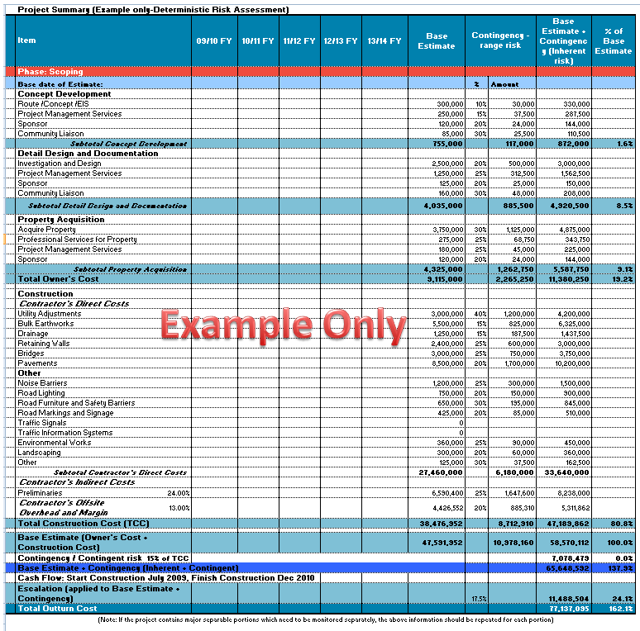

P . tS E I P b bT t• R. t A
Item 09110 FY 10111 FY 11112FY 12113 FY 13114 FY Base P50 PSO
Estimate
Phase:Sco m
Ia...dot• of

IRoute, 300,000 tServlces 250.000
ISponsor 120,000
Ualson 85.000

IDetailOesian and 1
Desio
tServlces 1.250.000
ISponsor 125.000
Ualson 160.000
•••••••

I Acquire Proper"
rlServices lor ProPertu 215.000 tServlces 180,000
ISponsor 120,000
... ,S!'!! -
I TotalOwner's Cost

Utlllt;

'OJ;,.,Co /$
•xa
..·-i• = Iii

I.A-·y

Drain••• IBrldaes
• ·::--· ":!' ... .. • • • . 1.250.000

IOther

150.000
650,000
425,000

rl\,lorks 360.000
300,000
Other 125.000
tCos!s

24.00%

.o::;; ;,

13.00%

I Total• r Cost ITCCI

IBase

r st)
Cost•
...
••• •••

t Risk

rJUI12009,Finish•
'Dec 2010 I

,.,.,.,,pootlo"wbl<h M<d to bo moolto«d "P'""''·tbo obo•< lofoomotloo ''"''d bo «p<>t<

APPENDIX B: EXPLANATORY NOTES - PROJECT PROPOSAL REPORT

Proponent and Project Details

A3 Project ID is assigned by the Department. For Development and Delivery Phase applications, the project ID assigned at Scoping Phase must be quoted.

A5 Project Scope should detail the specific design aspects of the project i.e. the road length and number of lanes to be constructed.

A6 Geographical references for the project should be provided in a MapInfo, MIF/MID or ESRI SHP file.

A7 A project summary should be prepared for possible inclusion on the Nation Building website. It should cover the entire project and include the rationale and performance objectives for the project, the outputs and expected benefits and the expected timetable for completion. The Australian Government/Proponent funding split should also be articulated. This summary should be no longer than one page.

A9 A project is eligible for approval as a National Project under the Act if the project is for one or more of the following:

a) the construction or maintenance of an existing or proposed road that is included in the National
Land Transport Network;

b) the construction or maintenance of an existing or proposed railway that is included in the
National Land Transport Network;

c) the construction of an existing or proposed inter-modal transfer facility that is included in the
National Land Transport Network;

d) the acquisition or application of technology that will, or may, contribute to the efficiency, security or safety of transport operations on the National Land Transport Network.

A project is eligible for approval as an Off-Network Project under the Act if the project is for one or more of the following:

a) the construction of an existing or proposed road, in a State or Indian Ocean Territory, that is not included in the National Land Transport Network;
b) the maintenance of an existing or proposed road, in a State or Indian Ocean Territory, that: (i) is not included in the National Land Transport Network; and
(ii) is in an area for which no local government authority has responsibility;

c) the construction of an existing or proposed railway, in a State or Indian Ocean Territory, that is not included in the National Land Transport Network;

d) the construction of an existing or proposed inter-modal transfer facility, in a State or Indian
Ocean Territory, that is not included in the National Land Transport Network;

e) the acquisition or application of technology that will, or may, contribute to the efficiency, security or safety of transport operations in a State or Indian Ocean Territory.

Note: The definition of construction covers some kinds of work on an existing road, railway or inter- modal transfer facility (hence the references above to the construction of an existing road, railway or inter-modal transfer facility).

Project Approach and Timing

D1 Increased funding from the private sector is an important factor in meeting future land transport infrastructure requirements. Participation by the private sector may include ownership, financing and operation, operation of business concessions, or financial contribution in recognition of specific benefits flowing from the project. The potential for private sector participation must be explored for all projects where the Proponent is a State or an authority of a State. Proponents should provide details of how the assessment was carried out and whether there is scope for private sector participation. A copy of the formal assessment should be provided. Where it is assessed that there is scope for private sector participation, the PPR should include details of how the procurement process will meet funding conditions set out in Section 4: Funding Conditions and other State procurement guidelines.

D2 A large land transport infrastructure project would typically have 20 to 40 milestones across the complete lifecycle, covering activities such as approvals, design, community engagement, land acquisition, infrastructure delivery, disruption management and handover. Milestones that provide potential for publicity (such as contract awarding, physical construction commencing or road / facility opening) should also be included.
A subset of these milestones should be identified as the project critical path. Typically 10 to
20 milestones would be on the critical path across the project lifecycle. Answers to questions in part D will form the basis of progress reporting for an approved project.

D3 Key assumptions underpinning the expected critical path should be articulated. This is particularly important where the proposed project is dependent upon delivery of other projects, State or Local Government Authority (LGA) planning approval or environmental impact studies.

D4 If the project critical path and milestones have not been approved by the relevant Proponent representative, the Proponent must provide details of how and when an approved project plan will be developed.

Financial Analysis

E1 Proponents should refer to the ‘Lift Out Guide to Best Practice Cost Estimation’ for guidance on the completion of the Outturn Investment Cost Table. The Standard itself should be seen as the primary reference document. Proponents should also take advantage of training offered by the Department in the application of the Standard.
It is important to note that each State has signed up to use of the Standard from 1 July 2009. Proponents submitting proposals after this date based on cost estimates that are not consistent with the Standard should not expect those proposals to be approved.

E2 Escalation can be assessed in an overall way by multiplying the cash flow for a specific year by the expected percentage increase to cover escalation for the entire cash flow in that year (as in the example Outturn Investment Cost Table). An alternative methodology can also be used that breaks down the annual expenditure into key components such as pavement, structures, drainage, etc for roads or formation, track, signalling, etc for rail and apply the expected unit price escalation percentages to each key element. The methodology used should be highlighted here.

E3 Escalation can be a significant component of the Total Outturn Cost, particularly for projects that are planned to start several years after the estimate date. The choice of escalation rates is therefore critical to achieving a realistic cost estimate.

E5 Volume 3 of the ATC National Guidelines for Transport System Management in Australia,
2006, provides a list of benefits that can be monetised for Benefit Cost Analysis. These are:

• Savings in vehicle / train operating costs

• Improvements in service reliability

• Savings in time costs for passengers and / or freight

• Savings in crash / accident costs

• Reduced environmental externalities (noise, pollution)

• Scrap or residual values of assets

• Savings in infrastructure operating costs including maintenance and administration

• Benefits associated with diverted and generated traffic

E6 The Evaluation Period should be set at the expected life of the asset created by the initiative. It is usual to assume a 30 year life for road initiatives (except bridges, which have much longer lives) and a 50-year life for rail initiatives. Intelligent Transport System initiatives will have shorter lives. If a longer life than 30 years is anticipated for a road initiative, the Evaluation Period should remain at 30 years with the residual value (defined as the present value of

benefits for the remaining life of the asset beyond the appraisal period) identified as an additional benefit.

E7 The BCR and NPV provided under E7 should reflect the figures provided for Option A under
E10.

E8 When analysing options, Proponents should consider how well each option addresses the main deficiencies and whether there is an adequate lower cost alternative to the proposal.
Detail how the proposed quality delivered by the project will be fit for purpose and no higher.

E10 Proponents should use the IBCR to compare options on economic grounds. The BCR is the present value of benefits less operating costs, divided by the present value of investment costs. IBCR is calculated in the same manner as the BCR but for the difference between options. On economic grounds, increases in the scale of a project are worthwhile as long as the IBCR exceeds one but budgetary considerations may result in a less costly, but still beneficial option being approved.
Note that the primary infrastructure operating cost is maintenance. Maintenance costs should be separated into annual (routine), periodic and rehabilitation categories.

• Annual (routine) costs may include vegetation control, repairs to pavements, signage/telecommunications equipment/ signalling/ train control systems, clearing drains/culverts and repainting line markings.

• Periodic costs may include resealing, stabilisation, re-sheeting, roughening concrete pavements, ballast cleaning, rail grinding, sleeper replacement and re-railing.

• Rehabilitation costs are major expenditures to substantially put the road/railway into as new condition.

Risk and Governance

F1 Proponents should identify the most significant risks to successful project delivery and provide details of the mitigation strategies proposed, including requesting increased Australian Government involvement where appropriate. Risks should be consistently defined, for example: ‘There is a chance that [event] will occur resulting in [impact]’. The likelihood and consequences of all significant risks should be provided and this should be consistent with the contingencies allowed in the cost estimates and benefit cost analysis sections.

F4 Factors that should be considered when determining the appropriate level of public and stakeholder participation may include:

• the potential for conflict over the project

• the potential for major social, environmental or economic impacts

• relevant legislative requirements

Supporting Data

1) Demand Forecasts

Benefits from transport projects are usually strongly related to the level of usage for infrastructure. Consequently demand forecasts play a critical role in project appraisal.

Demand forecasts should be provided for each option of the proposed project. Proponents should state the unit of demand which may include vehicle or train numbers; passenger numbers or gross freight tonnage/ containers.

The demand forecasts should be provided in accordance with the National Guidelines.

2) Safety Audit

A road or rail safety audit is a formal examination of a future or existing road or railway, in which an independent, qualified team reports on the project’s crash potential and safety performance.

A road or rail safety audit should be provided in accordance with the National Guidelines.

